# 

# **Department of Computer Science and Engineering Islamic University of Technology (IUT)** A subsidiary organ of OIC

# 

# **Laboratory Report**

# CSE 4412 : Data Communication and Networking Lab

## 

## **Name: Md Muktadir Mazumder Student ID: 190042136 Section: Lab Group - B Semester: 4th Academic Year: 2020-21**

**Date of Submission: 13/01/22**

**Lab 5**

### **Title:** Router Configuration and using static routing to connect multiple LANs in CISCO Packet Tracer. **Objective**:

1. Understand Default Gateway
2. Difference between Switch and Router.
3. Router to Router Wiring [Using DCE and DTE Cables]
4. Static Routing Configuration
5. Default Route

### **Devices/ software Used**:

1. Device: Personal Computer
2. Software: Cisco Packet Tracer

### **Diagram of the experiment:**

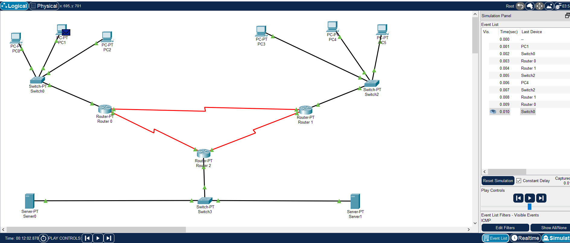

### **Theory:**

### Routing is a process which is performed by layer 3 (or network layer ) devices in order to deliver the packet by choosing an optimal path from one network to another. There are three types of routing: (1) Static Routing, (2) Default Routing and (3) Dynamic Routing. Our experiment subject is toConfigure routers to connect multiple LANs using the Static Routing technique. Static routing is the most secure way of routing. As it reduces overhead from network resources. In this type of routing we manually add routes in the routing table. Static Routing is useful where numbers of routes are limited and no bandwidth usage between routers.

**Default Gateway:**

A default gateway is the node in a computer network using the internet protocol suite that serves as the forwarding host (router) to other networks when no other route specification matches the destination IP address of a packet. It is basically the path used to pass information when the device doesn’t know where the destination is.

**Difference between Switch and Router:**

Router and Switch are both connecting devices in networking. A router is employed to settle on the shortest path for a packet to achieve its destination. Differences between Router and Switch on various aspects are given below:

|  |  |  |
| --- | --- | --- |
| **Key Points** | **Switch** | **Router** |
| **Objective** | To connect various devices simultaneously in a network. | To connect various networks simultaneously. |
| **Working Layer** | Switch works in the Data Link Layer. | Router works in Network Layer. |
| **Usage** | Switch used only in LAN. | Router is used in both LAN and MAN. |
| **Data Format** | Sends data in the form of Packets and Frames. | Sends data in the form of Packets. |

**Router to Router Wiring [Using DCE and DTE Cables]:**

Devices that communicate over a serial interface are divided into two classes: DTE and DCE. The most important difference between these types of devices is that the DCE device supplies the clock signal that paces the communications on the bus. In a Back to Back Serial Connection, the Clock must be set at the DCE side, a source of clocking is always needed in Asynchronous Serial Link, because the routers are connected directly, it's configured at the DCE side.

**Static Route:**

Static routing is a form of routing that occurs when a router uses a manually-configured routing entry, rather than information from dynamic routing traffic. In many cases, static routes are manually configured by a network administrator by adding entries into a routing table, though this may not always be the case. One of the differences between Dynamic Routing and Static Routing is that static routes are fixed and do not change if the network is changed or reconfigured.Static Routing is a routing mechanism handled by the Internet Protocol (IP) and that depends on manually configured routing tables.

**Default Route:**

The default route is generally the address of another router, which treats the packet the same way:

1) If a route matches, the packet is forwarded accordingly

2)  Otherwise the packet is forwarded to the default route of that router.

In computer networking, the default route is a configuration of the Internet Protocol (IP) that establishes a forwarding rule for packets when no specific address of a next-hop host is available from the routing table or other routing mechanisms.

**Configuration of Routers:**

**For Router 0:**

S 10.0.0.0/8 is directly connected, Serial3/0

11.0.0.0/24 is subnetted, 1 subnets

C 11.11.11.0 is directly connected, Serial3/0

12.0.0.0/24 is subnetted, 1 subnets

C 12.12.12.0 is directly connected, Serial2/0

S 170.70.0.0/16 is directly connected, Serial2/0

C 192.168.1.0/24 is directly connected, FastEthernet0/0

**For Router 1:**

C 10.0.0.0/8 is directly connected, FastEthernet0/0

11.0.0.0/24 is subnetted, 1 subnets

C 11.11.11.0 is directly connected, Serial2/0

13.0.0.0/24 is subnetted, 1 subnets

C 13.13.13.0 is directly connected, Serial3/0

S 170.70.0.0/16 is directly connected, Serial3/0

S 192.168.1.0/24 is directly connected, Serial2/0

**Router 2:**

S 10.0.0.0/8 is directly connected, Serial3/0

12.0.0.0/24 is subnetted, 1 subnets

C 12.12.12.0 is directly connected, Serial2/0

13.0.0.0/24 is subnetted, 1 subnets

C 13.13.13.0 is directly connected, Serial3/0

C 170.70.0.0/16 is directly connected, FastEthernet0/0

S 192.168.1.0/24 is directly connected, Serial2/0

**Observation**:

Running the Simulation mode, it has been observed that all the implemented three routers connecting the

different LANs created a new and separate network. And any device of any network can send packets to

any device of another network via routers.

**Challenges:**

At the time of configuring the Ip address of the serial ports of the routers, there was an error of ‘Overlapping with Serial Ports’. To solve this problem I switch over to the Config tab from the CLI tab and turn the required Port Status to ON. In some cases, data communication failed because the default gateway was not assigned. Alhamdulillah the experiment was done successfully; fixing all these errors.